Early Prediction of Sepsis from Clinical Data Using Classification Trees and Boosting Algorithms

Palash P. Thakur
Department of Electronics Engineering
Shri Ramdeobaba College of Engineering and Management
Nagpur,India
thakurpp@rknec.edu

Abstract— Sepsis should be defined as life-threatening organ dysfunction caused by a dysregulated host response to infection. Septic shock should be defined as a subset of sepsis in which particularly profound circulatory, cellular, and metabolic abnormalities are associated with a greater risk of mortality than with sepsis alone. Sepsis is a major public health concern with significant morbidity, mortality, and healthcare expenses. Early detection and antibiotic treatment of sepsis improve outcomes. However, while professional critical care societies have proposed new clinical criteria that aid sepsis recognition, the fundamental need for early detection and treatment remains unmet. In response, we have proposed tree based classification algorithms for early sepsis detection. Data used is sourced from ICU patients in three separate hospital systems. MS excel is used for data cleaning and based on vital signs of sepsis input features are selected. The algorithm is trained on 336456 patients. Decision trees are used as Base learners for Random Forest. Boosting algorithm like adaboost (Adaptive Boosting) is used for predictions on data. The overall ROC AUC score is 0.98-0.99. And the accuracy of testing set is 99.99%. However, the definition of sepsis is not yet exact and the algorithm can be improved further in future as per the updation in the definition of sepsis and in case of more available data.

Keywords—sepsis, CART, Decision tree, Random Forest, Adaboost,ROC AUC.

Introduction
Sepsis should be defined as life-threatening organ dysfunction caused by a dysregulated host response to infection. For clinical operationalization, organ dysfunction can be represented by an increase in the Sequential [Sepsis-related] Organ Failure Assessment (SOFA) score of 2 points or more, which is associated with an in-hospital mortality greater than 10%. Septic shock should be defined as a subset of sepsis in which particularly profound circulatory, cellular, and metabolic abnormalities are associated with a greater risk of mortality than with sepsis alone. Patients with septic shock can be clinically identified by a vasopressor requirement to maintain a mean arterial pressure of 65 mm Hg or greater and serum lactate level greater than 2 mmol/L (>18 mg/dL) in the absence of hypovolemia.
Key concepts of Sepsis:
- Sepsis is the primary cause of death from infection, especially if not recognized and treated promptly. Its recognition mandates urgent attention.
- Sepsis is a syndrome shaped by pathogen factors and host factors (e.g., sex, race and other genetic determinants, age, comorbidities, environment) with characteristics that evolve over time. What differentiates sepsis from infection is an aberrant or dysregulated host response and the presence of organ dysfunction.
- Sepsis-induced organ dysfunction may be occult; therefore, its presence should be considered in any patient presenting with infection. Conversely, unrecognized infection may be the cause of new-onset organ dysfunction. Any unexplained organ dysfunction should thus raise the possibility of underlying infection.
Sepsis can be in diagnosed by running following steps:
- Bacteria in the blood or other body fluids
- The source of the infection (he may use an X-ray, CT scan, or ultrasound)
- A high or low white blood cell count
- A low platelet count
- Low blood pressure
- Too much acid in the blood (acidosis)
- Altered kidney or liver function
The time required for the detection of sepsis takes hours. Each hour of delayed treatment has been associated with roughly a 4-8% increase in mortality. To help address this problem, we have proposed a predictive machine learning model. The model is based on tree based approach for structuring machine learning model. Which takes vital signs as input feature and based on that, it predicts output as 0 (For non-sepsis patients) and 1 (For sepsis patients).

Exploratory data analysis

Data Sources
Data used in the model is sourced from ICU patients in two separate hospital systems and is obtained from physionet website. Each hospital has 20,000 patients and hence 20,000 files which are provided in the form of pipe delimited text files. The text files are merged together into a single file using Microsoft Excel. Shape of the final appended dataset file is (1552287*41). Available patient’s co-variates consist of Demographics, Vital signs, and Laboratory values.

Input Feature Selection

After going through many journals and through health magzines, conference papers on the sepsis, we have filtered out most common indicator from all the sources on which sepsis depends. Those are named as vital signs and they are
Heart rate, Pulse Oximetry, Body Temperature, blood pressure (SBP, DBP), Mean Atrial Pressure, Respiration rate, Fraction of inspired Oxygen, Age, Gender, Hospital Admission Time and ICU length of stay.

Cleaining Dataset
A new dataset is prepared with only vital signs as input feature along with some demographics. The cleaning of dataset is done by using Microsoft Excel. The patients whose data is not available and having Nan (Not a number) values at the input are deleted.

Handling Imbalanced dataset
More than 98% data has sepsis label 0 while only 2 % has sepsis label 1. The data is imbalanced and result is misleading the final predictions thus the accuracy of the model cannot be estimated properly.

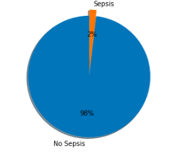

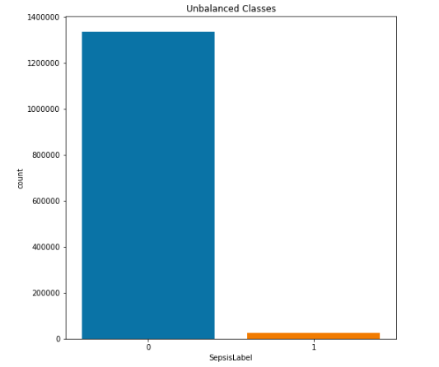
Before feeding this data into the model we are supposed to ensure that it has equal proportion of 0 and 1 value label for sepsis.
By analyzing the data, we have concluded that it has finite and less number of input features and hence SMOTE (Synthetic Minority Oversampling Technique) is best suitable for the data. Over sampling in SMOTE is done by selecting similar records and altering that record one column at a time by a random amount within this difference to the neighboring records. After over sampling the input data shape changed from (171755, 12) to (336456, 12). The dataset is then split into training and testing data by scikit learn library into 70% train and 30% test.

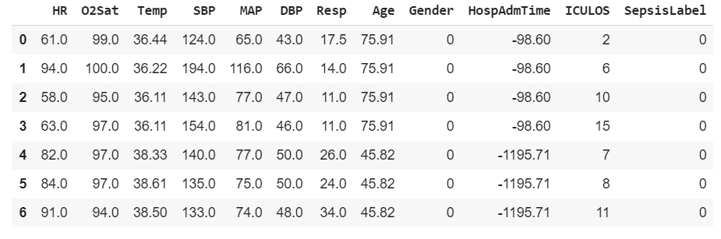
Sample dataset

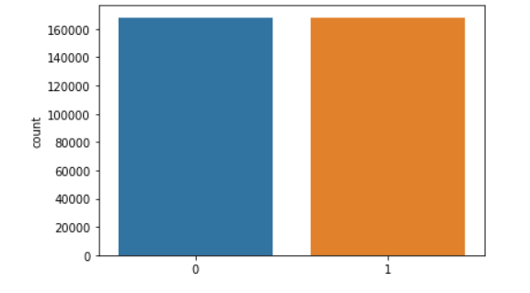

Tree Based Learning Approach

Decision Tree
Tree based learning is supervised machine learning where the data is continuously split according to certain parameters. The provided dataset is based on clinical data of patients and follows non-linear relationship between features and labels. Decision trees are able to capture non-linear relationships between features and labels. Decision tree doesn’t require feature scaling and works on real data.
Hence, by analysis of the provided data set tree based approach is best suited for the classification. The accuracy of the test set on decision tree is estimated to be equal to 70%. However, a single decision tree is often pruned and is less accurate and less stable. To overcome the above problem of decision tree, random forest algorithm is used. A sample decision tree is given:

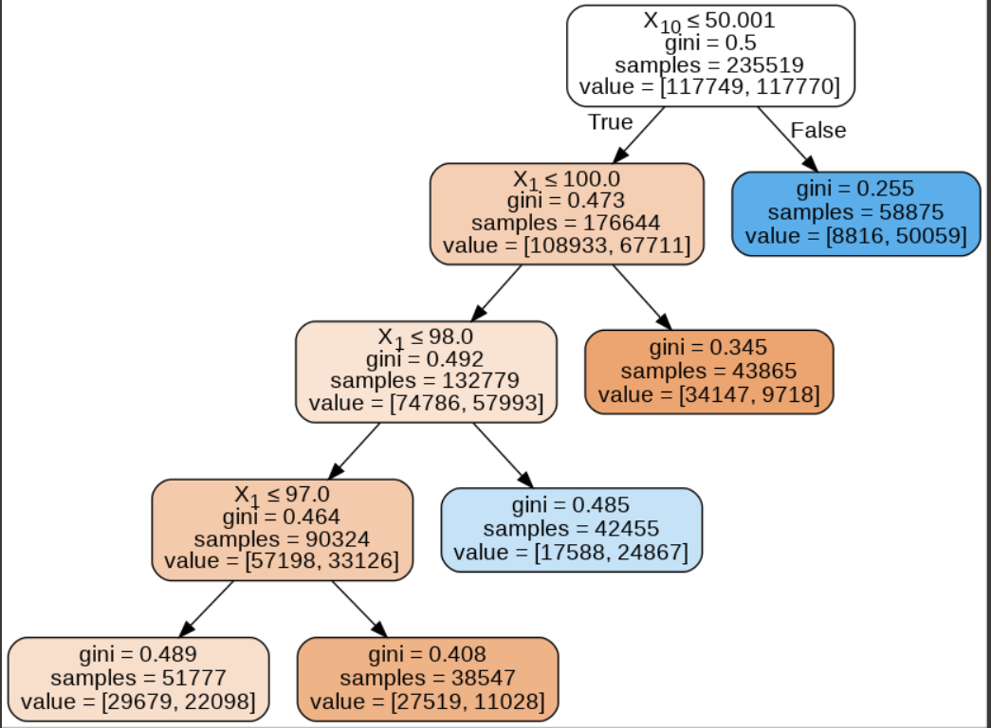

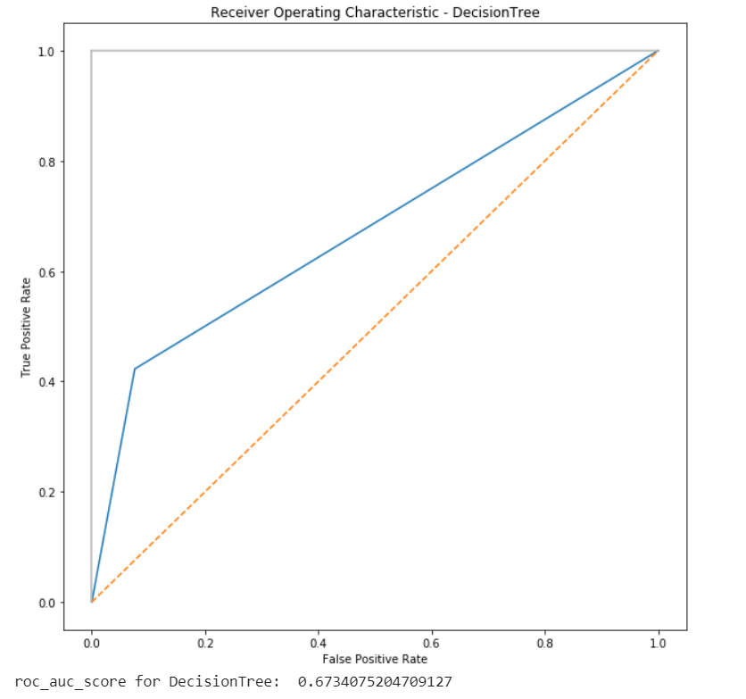

`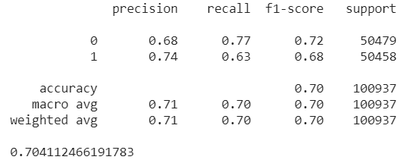

Further Diversity With Random Forest
Random forest uses decision tree as base learners where the number of decision trees are defined by an input parameter ‘n_estimators (number of estimators)’. The random forest classifier aggregates predictions by majority voting. In this model the output prediction of sepsis label is based upon the aggregate prediction of 20 decision trees i.e. there are 20 decision trees. The accuracy of the random forest on testing data is found to be greater than decision tree i.e. 98.997%.
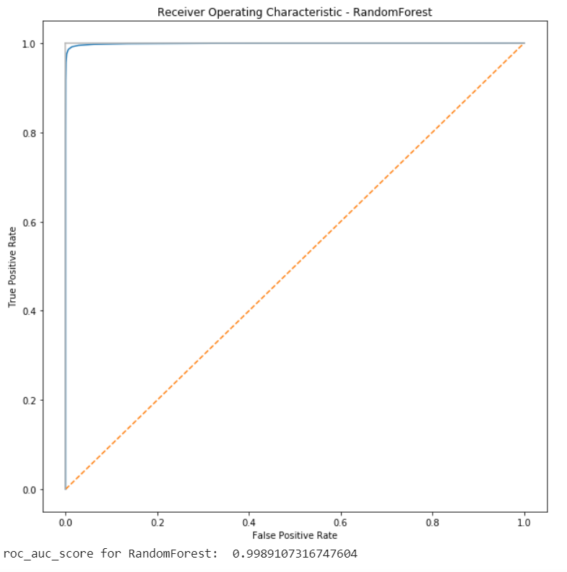
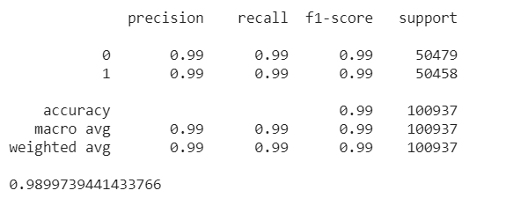

Boosting Methods
Boosting is ensemble method which combines several weak learners to form a strong learner. Boosting trains an ensemble of predictors sequentially and each predictor tries to correct its predecessor. The boosting method used here is adaboost which stands for adaptive boosting. In adaboost, each predictor pays more attention to the instances wrongly predicted by its predecessor achieved by changing the weights of training instances. For the further stability of random forest, it is used as base learner for adaptive boosting. The ROC (receiver operator curve) AUC (area under curve) score of adaboost is found to be equal to 1.00.
The accuracy of the model by using adaptive boosting is estimated to be equal to 99.72%

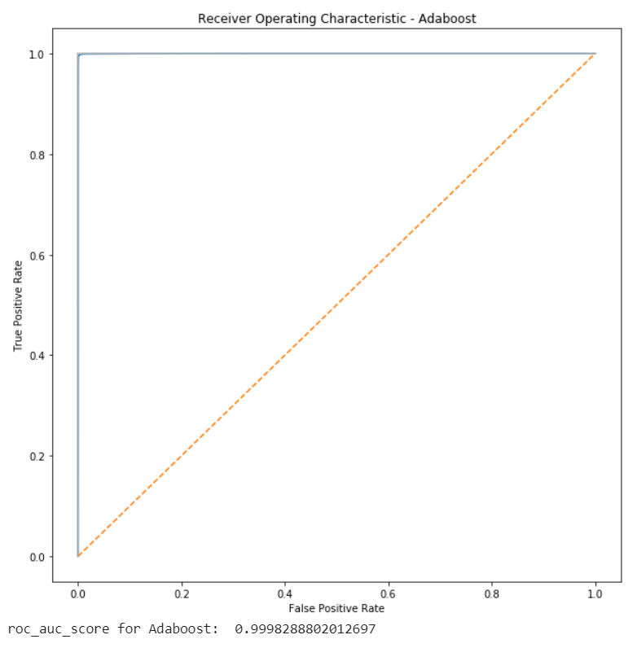

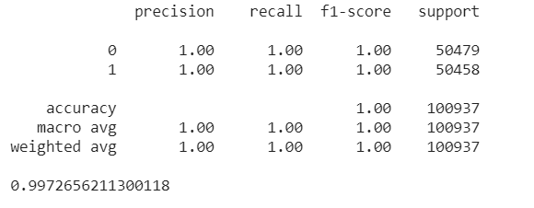

Keywords

Precision
Precision is defined as the fraction of relevant examples (true positives) among all of the examples which were predicted to belong in a certain class.

Precision = (true positives)/ (true positives + false positives)

Recall
Recall is defined as the fraction of examples which were predicted to belong to a class with respect to all of the examples that truly belong in the class.

Recall = (true positives) / (true positives + false negatives)

ROC AUC
AUC is an abbreviation for area under the curve. It is used in classification analysis in order to determine which of the used models predicts the classes best. An example of its application are ROC curves. Here, the true positive rates are plotted against false positive rates.

Conclusion
The prediction of sepsis is entirely based on vital signs i.e.
Physiological factors which does not require much time to estimate as compared to laboratory results. As seen from results it’s clear that adaboost outperforms on training as well as testing data. Still there are practical difficulties which can be solved over time by collecting more patient’s data and by building more robust algorithms.

References
- Physionet challenge:-Early prediction of sepsis from clinical data, 2019
- “Tree Based Learning” data camp
- The Third International consensus Definitions for Sepsis and Septic shock: Singer et al, 2016
- Wikipedia.
- Towards data science.
- US National Library of Medicine, National Institutes of Health​
- Centers for Disease Control and Prevention​
- Sepsis - The American Journal of Medicine

